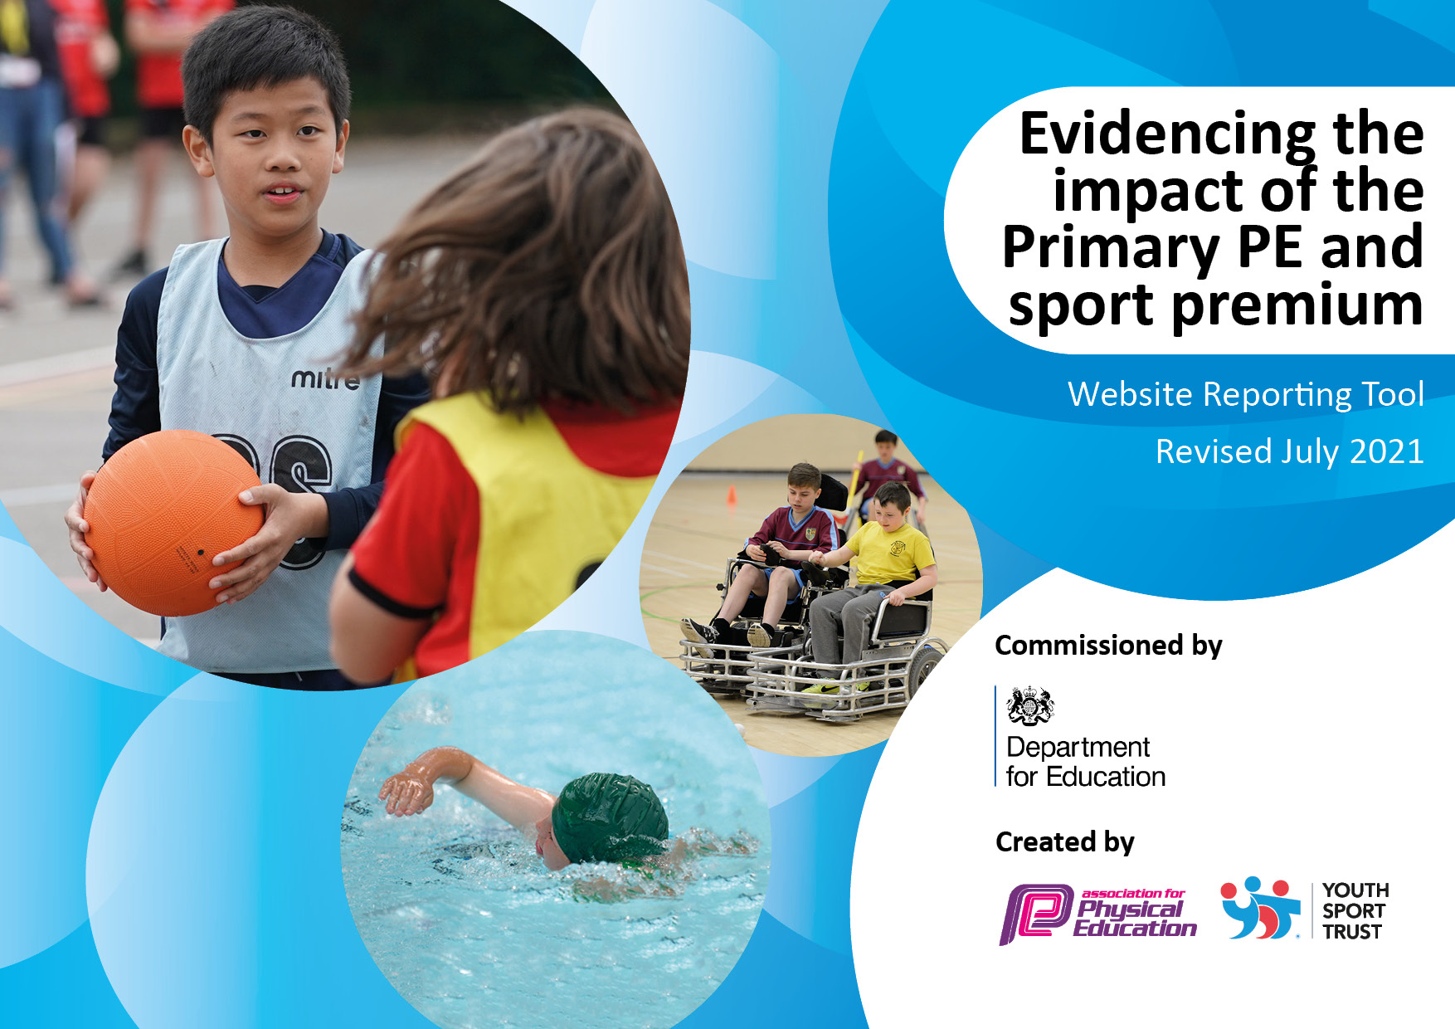
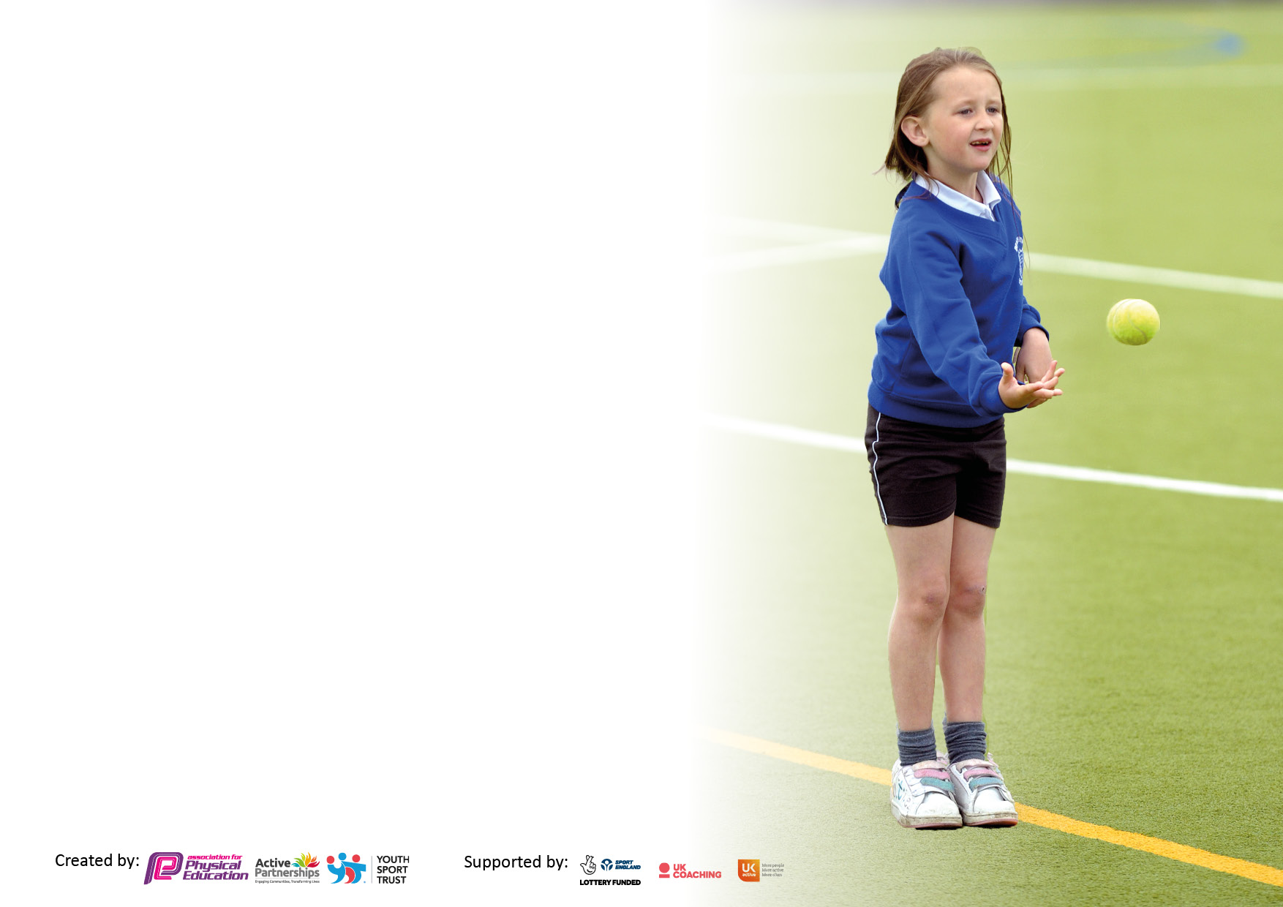

It is important that your grant is used effectively and based on school need. The Education Inspection Framework makes clear there will be a focus on ‘whether leaders and those responsible for governors all understand their respective roles and perform these in a way that enhances the effectiveness of the school’.

Under the Quality of Education Ofsted inspectors consider:
Intent - Curriculum design, coverage and appropriateness
Implementation - Curriculum delivery, Teaching (pedagogy) and Assessment
Impact - Attainment and progress

To assist schools with common transferable language this template has been developed to utilise the same three headings which should make your plans easily transferable between working documents.

Schools must use the funding to make additional and sustainable improvements to the quality of Physical Education, School Sport and Physical Activity (PESSPA) they offer. This means that you should use the Primary PE and sport premium to:

- Develop or add to the PESSPA activities that your school already offer
- Build capacity and capability within the school to ensure that improvements made now will benefit pupils joining the school in future years
- The Primary PE and sport premium should not be used to fund capital spend projects; the school’s budget should fund these.

Pleasevisitgov.ukfortherevisedDfEguidanceincludingthe5keyindicatorsacrosswhichschoolsshoulddemonstrate animprovement.Thisdocumentwillhelpyoutoreviewyourprovisionandtoreportyourspend.DfEencouragesschools to use this template as an effective way of meeting the reporting requirements of the Primary PE and sport premium.

We recommend you start by reflecting on the impact of current provision and reviewing the previous spend.

Schools are required to publish details of how they spend this funding, including any under-spend from 2019/2020, as well as on the impact it has on pupils’ PE and sport participation and attainment. All funding must be spent by 31st July 2022.

We recommend regularly updating the table and publishing it on your website throughout the year. This evidences your ongoing self-evaluation of how you are using the funding to secure maximum, sustainable impact. Final copy must be posted on your website by the end of the academic year and no later than the 31st July 2021. To see an example of how to complete the table please click HERE.
Created by: Supported by:

Details with regard to funding
Please complete the table below.

Total amount carried over from 2020/21 | £ 5815.00
Total amount allocated for 2021/22 | £ 18,390.00
How much (if any) do you intend to carry over from this total fund into 2022/23? | £ 00.00
Total amount allocated for 2022/23 | £ 18,590.00
Total amount of funding for 2022/23. To be spent and reported on by 31st July 2023. | £ 18,590.00
Swimming Data
Please report on your Swimming Data below.

Meeting national curriculum requirements for swimming and water safety.
N.B. Complete this section to your best ability. For example you might have practised safe self-rescue techniques on dry land which you can then transfer to the pool when school swimming restarts.
Due to exceptional circumstances priority should be given to ensuring that pupils can perform safe self rescue even if they do not fully meet the first two requirements of the NC programme of study
What percentage of your current Year 6 cohort swim competently, confidently and proficiently over a distance of at least 25 metres? | 90 %
What percentage of your current Year 6 cohort use a range of strokes effectively [for example, front crawl, backstroke and breaststroke]? | 81 %
What percentage of your current Year 6 cohort perform safe self-rescue in different water-based situations? | unknown
Schools can choose to use the Primary PE and sport premium to provide additional provision for swimming but this must be for activity over and above the national curriculum requirements. Have you used it in this way? | No

Action Plan and Budget Tracking
Capture your intended annual spend against the 5 key indicators. Clarify the success criteria and evidence of impact that you intend to measure to evaluate for pupils today and for the future.

Academic Year: 2021/2022 | Total fund allocated: £24,205.00 | Date Updated: 30 July 2022
Key indicator 1: The engagement of all pupils in regular physical activity – Chief Medical Officers guidelines recommend that primary school pupils undertake at least 30 minutes of physical activity a day in school |  |  |  | Percentage of total allocation:
 |  |  |  | 73%
Intent | Implementation |  | Impact | Sustainability and suggested next steps:
We aim to provide children with appropriate subject knowledge, skills and understanding. Allocated time will be given to all children throughout the school to continued High Quality sports provided by specialist sports coaches and teachers. Teaching and progression across the school is clear and consistent - all teachers and coaches use the scheme Get Set 4 PE  Widening cultural capital experiences for children. Outdoor Playground Improvement Project.  Supporting the Chief Medical Officer guidelines to undertake at least 30 minutes of physical activity each day. To encourage more sports opportunities for our pupils by continuing to promote active learning throughout the day, use in classroom of ‘Just Dance/Super Movers’ for children to be more active in school lessons. In addition active use of our daily mile.  Offer free after school clubs to all age ranges when available | PE is taught every week over 2 separate lessons using an interleaving approach to learning so that key concepts are repeatedly taught throughout EYFS, KS1 and KS2, ensuing that all children access PE sessions on a regular basis. In support of this, teachers have access to Get Set 4 PE plans and resources. The Get Set 4 PE platform, aligns with our core values, our whole child approach to PE and the objectives laid out in the National Curriculum.  GetSet4PE PE scheme purchased and rolled out across the school, all teachers to have access to the scheme and teach lessons according the long-term plan working alongside Get Set 4 PE.  Money put towards a larger budget for improving the quality of the playground surface and markings with a focus on developing an area which encourages opportunities for being an active school over the course of a day for internal and external PE providers. Project includes the provision of an external ‘Yoga’ matting to enable normal indoor PE lessons to be taught outside, freeing up hall space. To encourage more sports opportunities for our pupils.  5/10 minutes physical activities linked in with PE weaved throughout the day. Inside or outside using our daily mile or new playground equipment and active thermos-plastic markings.  We offer a range of different free clubs each term for all children to participate including:  Football  Netball  Multi-Sports  Cheerleading. | Funding allocated:  Get Set 4 PE  £880.00  (21-22 & 22-23)  £16,895.00  £0  £17,775.00 | Children are engaged in 2 hours of High-Quality PE with teachers or Sports coaches. Children show improvement of skills over the course of the term’s focus and are able to use this in teacher led lessons, including modelling skills and coaching of peers.  To develop a better quality of purpose-built active spaces within school. Children enjoy and are engaged in activities during structured PE lessons and break times.  Daily physical and health enhancing activities throughout the school day play a crucial role in our offer to children. Children are provided with opportunities outside of set PE lessons including active lessons, active breaks, active lunchtimes, yoga, mindfulness, our daily mile and extra-curricular activities. Developing healthier long-term habits. | Coaches to become familiar with children and aid teachers in assessment of skills shown by the children  All children coming through school to be able to use the facilities as the surfacing and structures will be permanent improvements.  Upskill Support staff in PE  Wider range of extracurricular activities.  Increase Year 6 Sports Crew responsibilities to help promote ‘active clubs’ at lunchtime.
Key indicator 2: The profile of PESSPA being raised across the school as a tool for whole school improvement |  |  |  | Percentage of total allocation:
 |  |  |  | 2%
Intent | Implementation |  | Impact | Sustainability and suggested next steps:
We want all children to experience a wide variety of sports and we will provide opportunities for children to become physically and socially confident which will enhance their health and life-long fitness. Improve staff understanding of PE curriculum, supporting a wide range of extra-curricular activities across the school.  Children aspire to perform the best that they can in sports competitions and clubs through providing incentives.  Provide appropriate equipment to support PE in line with Get Set 4 PE scheme of work and to provide opportunities for a wide range of activities across the school day.  Develop opportunities for pupil engagement with PE and sport throughout the school. | Money available for classroom cover to allow PE lead time to attend CPD, meetings with external sport providers, leadership time.  Stickers purchased for sports days.  Complete a PE audit and staff survey for any gaps in required (or wish list) PE equipment. Purchase new or replacement equipment and resources.  Encourage sporting opportunities for all and raise the profile of PE and sport as a toolkit for positive wellbeing and confidence. | Funding Allocated:  (£700.00)  £50.00  £300.00  £350.00 | Staff understanding of PE curriculum has increased. A wider range of extra-curricular activities has been provided across the school. Provision of specialist coaches and equipment, including a large playground project.  Children perform the best that they can in sports day events.  Children are accessing appropriate PE equipment.  Children given opportunities to access a wide range of sporting activities leading to a healthy and active adulthood. | Maintain links with external providers. Remain up to date with PE curriculum requirements.  Stickers provided the following year. Source new trophy for Sports Day.  Equipment will be kept safe and easy to access and will be seen as equipment to be proud of and looked after  Embed Sports Crew. Sports Crew to be trained and will help to deliver activities at lunchtime. Explore wider range of extracurricular activities.

Key indicator 3: Increased confidence, knowledge and skills of all staff in teaching PE and sport |  |  |  | Percentage of total allocation:
 |  |  |  | 3%
Intent | Implementation |  | Impact | Sustainability and suggested next steps:
We want teachers to aspire to teach a high-quality physical education curriculum inspiring all pupils to succeed and excel across a plethora of physically demanding activities. Subject leader to articulate a clear and current vision for PE and ensure the highest standards for staff and children.  Improved subject and skills knowledge for all teaching staff and support staff. | Staff CPD. Opportunities for PE Subject Leader and school teaching staff to develop skills and knowledge in order to lead and teach PE effectively within school.  PE lead to attend PE conference and local CPD events.  In order to develop achievement in PE for all pupils, specialist coaches will deliver high quality PE lessons. In order to upskill all staff, teachers will have opportunities to observe and monitor the delivery of all specialist-coaching lessons to aid their own delivery of PE lessons. | Funding Allocated  £700.00  £700.00 | Support for subject leader to articulate a clear and current vision for PE and ensure the highest standards for staff and children. Teachers supported to deliver high quality PE sessions and clubs.  Sports coaches are seeing the impact on the progression of skills across the whole school  Staff have become more confident in using and applying sports coaching skill to own lessons  Staff have the ability to improve continually through use of PE scheme. | Capability of Subject Leader to lead PE in school enhanced for future years. All teaching staff will be teaching effectively.  Further opportunities to work alongside specialist coaches.  Funding set aside to renew Get Set 4 PE.
Key indicator 4: Broader experience of a range of sports and activities offered to all pupils |  |  |  | Percentage of total allocation:
 |  |  |  | 22%
Intent | Implementation |  | Impact | Sustainability and suggested next steps:
Use of IT to support learning across the school. Including the ability to demonstrate key skills to children outside of the classroom environment.  Provide a safe environment for children to access PE equipment.  We want our PE curriculum to inspire pupils with a curiosity and fascination with the key skills of physical education. Providing a broad experience of a range of sports activities. Strong community link developed with a local sports club and its coaches as well as new sports added to the school curriculum.  Develop opportunities for alternative sports within the school which are away from the norm.  Children able to access extracurricular activities. | Purchase of two laptops. Laptop to show slides, demonstration videos and dance warm-ups. Subject leader to collate data, observe lessons and fulfil other aspects of PE SL role effectively.  Repairs to damaged PE equipment. Annual safety check and maintenance of Equipment. A variety of equipment to be purchased identified needs based on analysis of current inventory.  Links with Lincoln College to provide coaching and CPD opportunities.  Cheerleading club provided by local dance academy.  Yoga and dance lessons provided by local dance academy.  Multisport extra-curricular clubs provided by local organisation- Joy Foundation.  Qualified PE teacher paid to run afterschool multi-sports clubs.  Qualified Football Coach to run afterschool Football clubs.  Teacher to run Netball club  Circus workshops focussing on alternative physical education activities, widening experiences for children.  Survey children as to what extra sports they may like to see happen in the school.  Y6 Water Sports Day, hiring water sports venue for sessions using their facilities and trained coaches | Funding Allocated:  £1080.00  £250.00  £2500.00  £1600.00  (2021 & 2022)  £5430.00 | Lessons will be more effective and pupils will receive a broader experience of each sport, skill or game taught.  PE equipment is safe for use across the school.  High quality equipment is available for PE lessons, after-school clubs and break-times in a variety of sports.  Work with partners in Lincoln to develop links to sports clubs or community-based sports providers so that more children engage in a wider range of community sports clubs and projects.  Opportunities for children across the school to try out different sports and access high-quality coaching.  Children will feel valued when coming forward to suggest ideas for news sports curriculum ideas  Children will feel less inhibited when taking part in an activity they had not considered was a sport for them to take part in.  KS1 Children given opportunity to explore non-conventional sporting activity. Developing healthier long-term habits. | These laptops will be available for all future PE use in school beyond this year.  Annual audit and maintenance of PE equipment.  Durability and safety of equipment is prioritised.  A culture of regular participation in after-school sports clubs embedded across the school.  Explore more opportunities for children across the school to try out different sports and access high-quality coaching.  Develop Sports Crew - Young leaders delivering lunch clubs.  Playground Leaders Award  Continue looking into specialist coaches/trainers to deliver any sports opportunities. Particularly Netball and Football.
Key indicator 5: Increased participation in competitive sport |  |  |  | Percentage of total allocation:
 |  |  |  | % 0
Intent | Implementation |  | Impact | Sustainability and suggested next steps:
We will inspire all children to develop a love of physical activity, teamwork and competition.  We will offer opportunities for children to compete in activities that build character and help to embed values such as fairness and respect. We want to teach children to cope with both success and failure in competitive, individual and team based physical activities. | Our PE lessons encourage children to compete against both themselves and others whilst being challenged to improve physical, social, emotional and thinking skills. These skills are embedded in the heart of all our planning. We will provide in house competitions at end of each term demonstrating skills taught during the term. Annual Sports Day – inter-school house events.  Schools Games and local competition-minimal participation during this academic year. | Funding Allocated  £ 0 | Children across the school given opportunities to participate in internal competitions. | Increase opportunities for competitive sport outside of school, including activities organised by School Games and local school events.  Increase in house competition across key stages.  Develop this more to include a higher ration of the school in competitive sport

Signed off by
Head Teacher: | Mrs F Kent | Date: | 20th July 2022
Subject Leader: | Mrs S L Blockley | Date: | 20th July 2022
Governor: | Mrs S Charman | Date: | 20th July 2022

