Year Group | Year | Autumn 1 |  | Autumn 2 |  | Spring 1 | Spring 2 |  | Summer 1 |  | Summer 2
Reception, Year 1 and 2 | A | 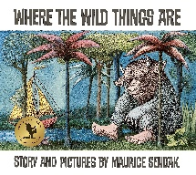  Where the Wild Things Are – Own version wild thing narrative  Labels, captions, oral re-telling, developing a new character  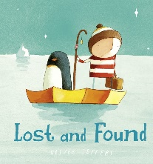  Lost and Found – Own version losing/finding narrative  Character descriptions, retellings, advice letter, instructions, fact-file |  | 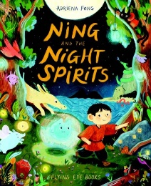  Ning and the Night Spirits – Information text about nigh spirits  Posters, letters of advice, party invitations  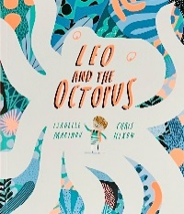  Leo and the Octopus  This is me! Posters, letters of advice, factual descriptions, logbooks, scripts |  | 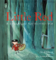  Little Red – Alternative character version  Labels, notes of advice, adverts  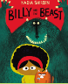  Billy and the Beast – Own version ‘defeat a monster’ narrative  Wanted poster, summary, emails, character description, recipes | 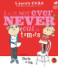  I Will Not Ever Never Eat A Tomato – Own story about a fussy eater  Statements, writing in role, lists  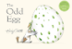  The Odd Egg – Egg-spotter's guide (non – fiction report)  Short guide, thought bubbles, awards, letter, predictions, congratulations cards |  | 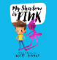  My Shadow is Pink – Leaflet  Innovated spoken rhymes, questions, notes of advice, lists, instructions  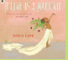  Julian is a Mermaid – Three – verse poem  Wishes, commands, though bubbles, labels and adverts |  | 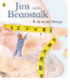  Jim and the Beanstalk – Sequel story  Narrative re-telling 9Incluiddng dialogue), thought bubbles, informal letters    Astro Girl – Fact file about being an astronaut  Writing in role, commands, how to guides
Reception, Year 1 and 2 | B | 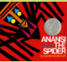  Anansi the Spider – Booklet about Spiders  Labels and captions, call-and-response poems, descriptive posters, simple explanations  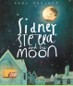  Sidney, Stella and the Moon – Fact file about the moon  Lost poster, labels, glossaries |  | 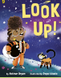  Look Up – Narrative Own version  Signs and labels, thought bubbles, flyers, letters of advice  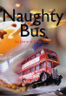  Naughty Bus – Own adventure story  Letters, diaries, captions, fact files on buses |  | 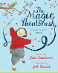  The Magic Paintbrush – Own version overcoming tale  Thought bubbles, labels, oral retelling, writing in role, thank you letters  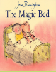  The Magic Bed – Own fantasy story  Setting description, additional scene, description of magical piece of furniture, list | 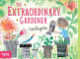  The Extraordinary Gardener – Narrative inspired by the original text  Labels, letters of advice, instructions, narratives  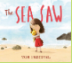  The Sea Saw – Own version narrative  Writing in tole, notes of advice, missing posters, diary entries, letters of thanks |  | 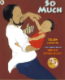  So Much – Own So Much narrative poem  Past tense sentences, writing in role, performance/narrative poetry  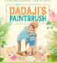  Dadaji’s Paintbrush – Guide book  Labels, captions, character comparisons, thought and speech bubbles, a fact file |  | 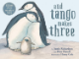  And Tango Makes Three – Alternative version narrative  Signs and lists, writing in role, letters of advice, ‘new baby’ cards  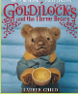  Goldilocks using three different versions – by Lauren child, Anthony Browne and Leigh Hodgkinson – Sequel story  Wanted posters, letters, retellings, speech bubbles, retellings from another point of view
Reception, Year 1 and 2 | C | 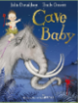  Cave Baby – Narrative re-telling  Labels and captions, posters, informal letters  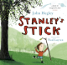  Stanley’s Stick- Own version narrative  Book of sticks’ entry, speech bubble, thought bubble, postcard |  | 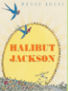  Halibut Jackson – Narrative sequel  Signs and labels, captions, invitations, thought bubbles, advertisements, letters of advice  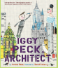  Iggy Peck – Fact file about famous buildings  Labels character comparisons, character description, building description, posters |  | 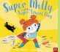  Super Milly and the Super School Day – Alterative character version  Letters of encouragement, a retelling, song lyrics and job applications  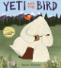  Yeti and the Bird – Own version narrative about an unlikely friendship  List of rules, letters, postcards, character descriptions |   The Tiny Seed – Advice leaflet  Labels and captions, re-telling writing in role, narrative, letter  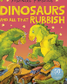  Dinosaurs and all that Rubbish – Pamphlet  Letters, Setting Descriptions, instructions, narrative (retelling), Pamphlets, posters |  | 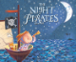  The Night Pirates – How to be a pirate guide  Writing in role, letters, labels and captions  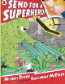  Send for a Superhero – Own version superhero narrative  Wanted posters, letters, character descriptions, captions |  | 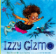  Izzy Gizmo – Simple explanation  Signage, letters of advice, lists, labelled diagrams  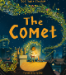  The Comet – Own version narrative  Posters, letters of advice, poems, descriptions, writing in role, recipes
 |  | Autumn 1 |  | Autumn 2 |  | Spring 1 | Spring 2 |  | Summer 1 |  | Summer 2
Year 3 and 4 | A | 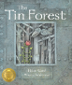  The Tin Forest – Persuasive information poser  Persuasive posters, information leaflets, postcards, diary entries, wishes, setting descriptions.  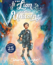  The Lion and the Unicorn – Own version historical narrative  Letters, diary entries, character and setting descriptions, non-chronological reports |  | 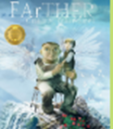  FArTHER – Sequel Story  Retellings, recounts (postcards), setting descriptions, diary entries, instructions.  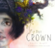  The Crown – Information text for a ‘Book of Wonders’  Descriptive labels, dairy entry in role, descriptive poems, ‘good news’ posters. |  | 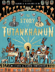  The Story of Tutankhamun – Biography of Howard Carter  Non-chronological reports, instructions, character descriptions, diary entry, newspaper reports and posters  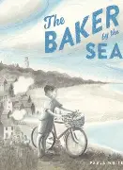  The Baker by the Sea – Tourist brochure  Job applications, advertisements, setting descriptions, letter in role. | 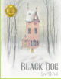  Black Dog – Own version ‘suspense’ narrative  Postcard, dialogue, retelling, description  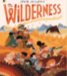  The Wilderness – A guide to enjoying the wilderness  Character introductions, letter of advice, descriptive poem, SOS message, identification label |  | 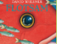  Flotsam – Sequel (Mystery narrative)  Postcards, setting descriptions, non – chronological reports, message in a bottle letters  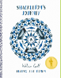  Shackleton’s Journey - Newspaper report  Packing lists (justifications), letters (formal and informal),  Setting descriptions, interviews, dairies, dialogue |  | 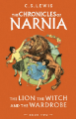  The Lion, the Witch and the Wardrobe – Own version narrative (set in another world Poem, eyewitness report, an imaginary conversation, writing in role  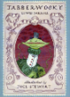  Jabberwocky – Nonsense poem  Performance poetry, explanatory description  speech
Year 3 and 4 | B | 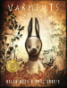  Varmints – Explanation of a life cycle  Diary entry, instructions, letter, description  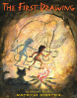  The First Drawing – Own historical narrative  Character description, diary entry, recount |  | 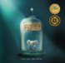  The Barnabus Project - Brochure  Instructional writing (escape plan, experiment), descriptions, advertisements, letters of advice, dialogue  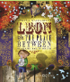  Leon and The Space Between – Own version of a fantasy narrative  Persuasive poster, performance reviews, setting description, thought bubbles / diary entry, dialogue |  | 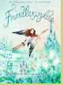  Frindleswylde – Narrative sequel  Letters, voting slips, dialogue, poetry, birds-eye view descriptions, persuasive speeches  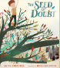  The Seed of Doubt – A motivational leaflet about future dreams and aspirations  Poetry, future dreams and aspirations, setting description, letter of advice, paper aeroplane message, character description, speech | 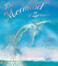  The Mermaid of Zennor - Own version of legends  Information booklets, retelling from a different perspective, letters, tourist guides  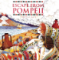  Escape from Pompeii – newspaper report  Setting descriptions, diaries, letters, thought bubble |  | 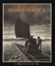  The Mysteries of Harris Burdick – Extended fantasy narrative  Setting description, short first person narrative, dialogue, action scene.  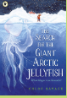  The Search for the Gian Arctic Jellyfish – Non-chronological report  Expedition proposals, persuasive letters, letters, diary entries, poetry, speech |  | 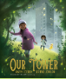  Our Tower – Extended fantasy narrative  Poems, setting descriptions, diary entries, dialogue, letters of thanks.  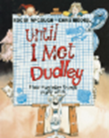  Until I Met Dudley – Two explanation texts – formal and informal  Explanatory poster, letter, short explanatory paragraph
 |  | Autumn 1 |  | Autumn 2 |  | Spring 1 | Spring 2 |  | Summer 1 |  | Summer 2
Year 5 and 6 | A | 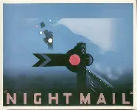  Night Mail – Poem with similar structure  Summaries, analysis and performances  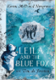  Leila and the Blue Fox – Extended blog entry  Poetry, informal message, formal letter, short information text, diary entry, narrative and action scenes, tweet |  | 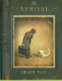  The Arrival – Narrative retelling (extended)  Letters Character descriptions, diaries, poster, short playscripts, short report    Can We Save the Tiger? - Discussion text  Letter, explanation, persuasive poster, persuasive speech, Simple Poem |  | 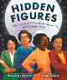  Hidden Figures – Non-Chronological report on the life and achievements of the women and history of NASA/NACA  Non-Chronological reports, job adverbs, formal persuasive letters, informal letters, diary entries, character descriptions, opinion pieces.  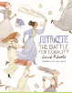  Suffragette, The Battle for Equality – Persasive campaign  Formal letters, diary entries, balanced arguments, speeches, short news report | 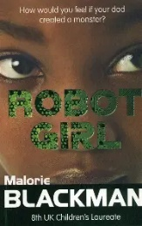  Robot Girl – Science-fiction narrative  Discussion/debate, character comparisons, dialogue, email in role, setting description, advice letter, action scene, book review  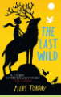  The Last Wild – Owen version dystopian narrative  Poster, retellings, formal report, character descriptions, diary entries, formal letters. |  | 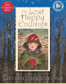  The Lost Happy Endings – Prequel – alternative perspective  Letter, poetry, passage of direct speech, diary entry, story ending  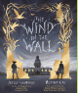  The Wind in the Wall – Extended Gothic narrative  Horror film poster, figurative writing, character/setting descriptions, old English letter, dialogue |  | 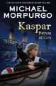  Kasper Prince of Cats – Newspaper article  Character descriptions, reports, letters, advertising leaflet, balanced report    Some Places More Than Others – Poetry  Letters, diaries, information leaflets, instructions
Year 5 and 6 | B | 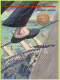  The Man Who Walked Between Towers – Biography  Fact files, journalistic writing, setting descriptions, letters of advice, persuasive speeches.  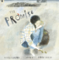  The Promise – Sequel to continue the cyclical story in the from of a narrative poem.  Promises, extended thought bubble, diary entry, leaves for a 'mood tree', letter in role, figurative captions, poem to summarise the story | 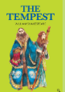  The Tempest – Playscript  Setting description, character descriptions /comparisons, diary entry, dialogue  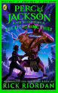  Percy Jackson and the Lighting Thief – Own version mythical narrative  Poetry in the form of an ode, soliloquy, setting descriptions, diary entries, additional chapter, non-chronological reports |  | 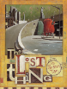  The Lost Thing – Own version narrative about a ‘lost thing’  Diary entries, formal letters, guides / non-chronological reports, adverts, official paperwork, lost tags  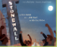  Stonewall – Visitor's guide to the Stonewall Inn National Historic Landmark.  Adverts, short news reports, protest banners, writing in role |  |  | 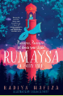  Rumaysa: A Fairy Tale – Fairy tale reworking (prequel)  Warning poster, diary entry, dialogue, villain's lair advert, character description, missing narrative  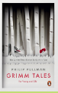  Grimm Tales for Young and Old – Own version traditional tale  Retelling from a particular viewpoint, analyses, dialogue |  | 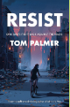  Resist A biography of Audrey Hepburn  Resistance recruitment posters, diary entries, journalistic pieces, persuasive leaflets, fictional biographical paragraph  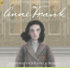  Anne Frank – Newspaper article  Letters, short descriptions, extended diary entries, obituary, optional opinion piece |  | 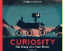  Curiosity: The Story of a Mars Rover – Expanded explanation for a new rover  Proposal to NASA, Information Labels, Short explanation, NASA log of Mars landing, news report  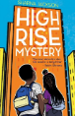  High Rise Mystery – Extended Narrative  Character description, police report, setting description, newspaper article, dialogue, formal persuasive letter.

