Waddington Redwood Primary Academy - Attendance

Why Attendance is important:
At Waddington Redwood Primary Academy, we believe attending school regularly is important for your child’s achievement, wellbeing, and wider development. Evidence shows that children with the highest attendance throughout their time in school gain the best GCSE and A Level results. (Education Hub - here)
The link between attendance and attainment is clear:
• In 2018/19, just 40% of persistently absent (PA) children in KS2 achieved expected KS2 standards, compared with 84% of pupils who were regular attenders.
Attendance policy link here
Attendance Expectations:
Regular school attendance is an important part of giving children the best possible start in life. The aim should be to attend 100% of the time.
Children who miss school frequently can fall behind with their work and do less well.
School attendance:
Attendance percentage | Boundary
95 to 100% | As expected
91 to 94% | At risk of persistent absence
80 to 90% | Persistent absence
51 to 79% | At risk of severe absence
Less than or equal to 50% | Severe absence
LCC Attendance Strategy here
If you have concerns or need support with your child’s attendance, please contact the academy as soon as you can to ensure early support is available.
Punctuality:
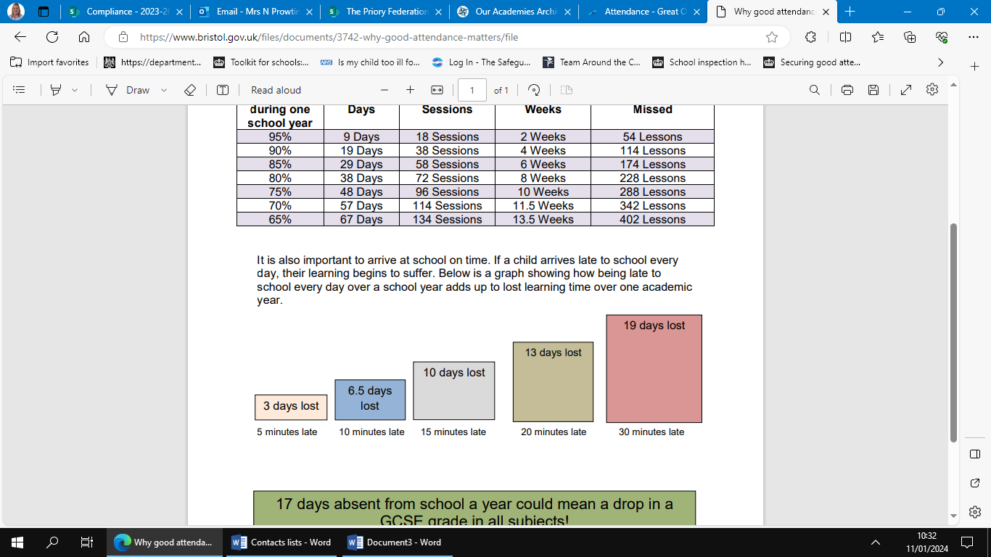
It is also important to arrive at school on time. If a child arrives late to school every day, learning begins to suffer. Below is a graph showing how being late to school every day over a school year adds up over one academic year. The academy day begins at 8.45am with the gates opening and lessons start at 9am prompt.

Absence Processes:
The Academy has clear processes to manage absence. These can be found here

Term Time Holiday and Requesting a Leave of Absence:
Term-time holiday will not be authorised and could result in a fixed penalty fine. Only exceptional circumstances warrant a leave of absence. Academies will consider each application individually, taking into account the specific facts and circumstances and relevant background context behind the request.
A LOA request form can be found here
What can parents/carers do to support their child?
- Support their learning.
- Talk positively about school and let your child know you're there to support their learning at home,
- Support them at exam time,
- Attend parents' evenings
As much as you can:
- Go along to other school events.
- Develop their resilience – is your child really too ill to attend school?
Is my child too ill for school? - NHS (www.nhs.uk)

