Some examples of SMSC learning opportunities

At Waddington Redwood Primary Academy, we promote SMSC in many ways. Some examples of how we do this are below.
Kindness Day
Kindness Day is an important date in Redwood’s calendar. During our Kindness Day last year, the children and staff helped to spread a little kindness. This day was organised by our Anti-Bullying Ambassadors and supporting adults.
On Kindness day, we explored how small acts of kindness can have a huge impact on an individual’s life and self-esteem. We looked at how we can promote kindness and help to brighten up someone’s day, every day. Redwood’s pledge for Kindness Day was as follows: ‘We pledge to show care, respect and kindness to each other’. During the day, the children took part in many activities such as; share and give a compliment parachute games; creating a class ‘Kindness Web’; giving each other special names; creating friendship flowers; designing a poster to promote kindness and giving each other compliments during the day.
The Upper KS2 children also completed English work based around the book ‘Wonder’, by RJ Palacio. This book looks at a young boy who has a facial disfigurement. It explores how acts of kindness can change feelings and stereotypes, helping to make people’s lives better.
During Kindness Day, every child also had a Kindness day card. On this kindness card, every act of kindness was recorded and signed for by an adult. At the end of Kindness day, the child with the most recorded acts of kindness in each class won a small prize.
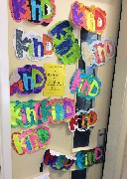
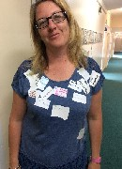
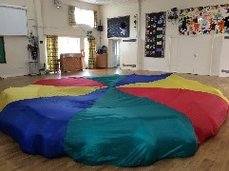

Kindness Day Award
As part of our Kindness Day activities in 2016, we entered our school into the Kindest School in the UK competition run by the Diana Award. We were very happy when we received the news that we had won the title: The Kindness Day School Award 2016! You can find our certificate in the front entrance of the academy. Due to our win, we had a visitor from the Diana Award organisation, who presented our certificate and gave us the news that we had won £500 worth of books for our library. We also had a visit from Lincolnshire Echo!
British Values Day
At Redwood, we regularly hold ‘British Values Day’. This is a day where we focus on raising the children’s awareness of British Values and aim to develop their understanding of what it means to be British. As part of our British Values Day, we invite the children to come into our academy wearing the British colours: red, white and blue. During the day, the children explore and develop a knowledge of the British Values and what they mean. The children explore the following values: mutual respect, the rule of law, democracy, tolerance and individual liberty. The children also explore how they are different and what makes them unique. We then link this to our British Value, tolerance. We discuss how being different is acceptable and how we should welcome and accept each other regardless of race, religion, gender or disability.
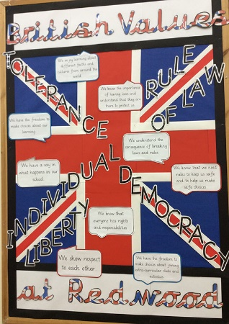


Christingle Service
Our SMSC work links very closely to our Religious Education. As part of the Foundation and Key Stage 1 curriculum, each year the children learn about the Christingle Celebration. This year Reverend Annabelle and Reverend Rachel came to teach the children about the Christingle Service. The children discovered that the Christingle represents various things: the orange represents the world, the red tape represents Jesus’ blood, the 4 sticks represent the seasons, the fruit and good things of the Earth and the candle in the middle represents Jesus being the light of the world. As part of the children’s learning about the Christingle service and its representation, the children also found out about the good work the Children’s Society do to support young people using the funds made at Christingle services. Redwood helps to raise money for this important charity by inviting parents and carers to attend a carol/Christingle service.

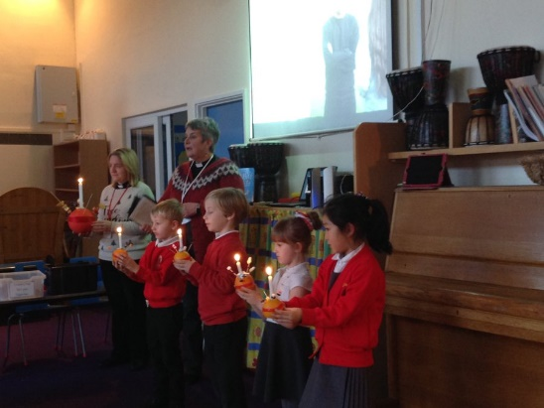
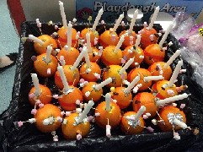

Anti-Bullying Week
Each year at Waddington Redwood, we hold an Anti-Bullying Week alongside other schools in the country. This year the theme for the week was ‘Change starts with us’. During the week, the children undertook many different activities related to this very important issue. The children explored ways to tackle and stand up to bullying and what they can do if they feel they are being bullied or notice someone else being bullied.
Anti-Bullying week is a great chance for our Anti-Bullying Ambassadors to promote their work. The Ambassador team delivered an assembly to KS1 and KS2 on what bullying is, as well as on their role within school. During this time, they also helped to address any misconceptions that their fellow pupils had. During Anti-Bullying week, the ambassadors also set the rest of the school a challenge - to design a poster that could be displayed around school to promote Anti-Bullying.
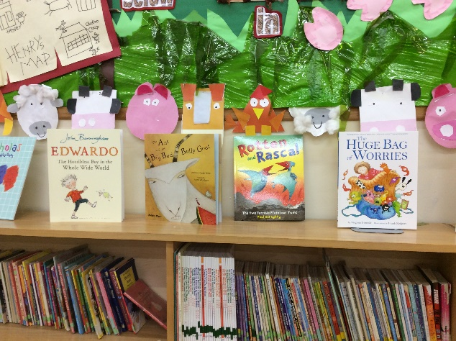
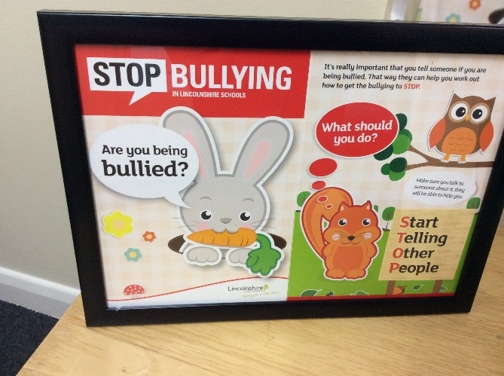
SMSC comes hand in hand with the events that we run throughout the year, Anti-Bullying Week being one of the most important.
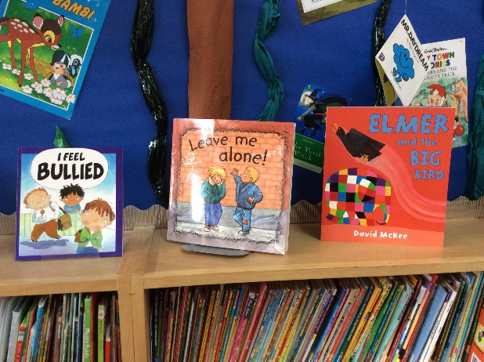
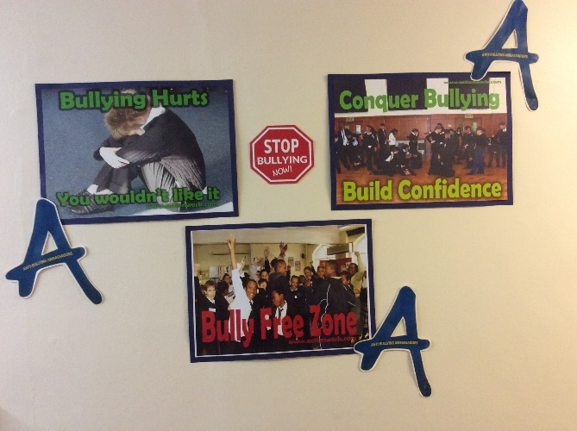

Children in Need
Each year Redwood takes part in Children in Need day. This year was no exception. The children dressed up in spotty clothes and brought in a small donation. The children learnt about where the donations/money would go and the good it would do for disadvantaged children. In total, we raised £281. Well done Redwood!
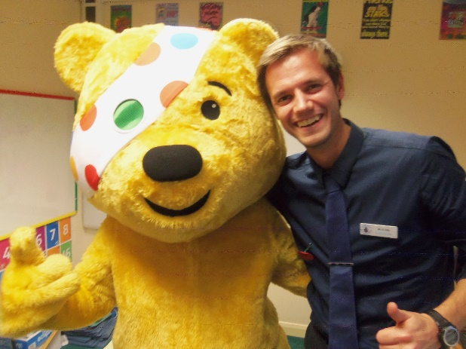
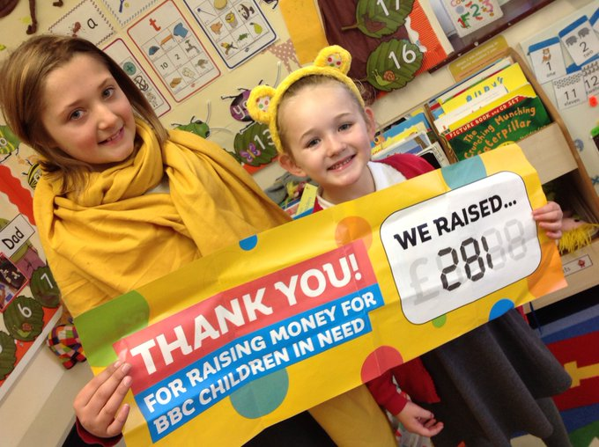

Musical, artistic and creative experiences
A range of opportunities are provided across the year for children to show off their musical, artistic and creative talents. Children in Years 3 and 4 learn to play a stringed instrument and then get to perform in their own concert to parents so they can show their newly learnt skills. Our talented singers attend the annual Young Voices event at Sheffield Arena. As well as this, each week all children come together to practice their singing skills as a part of our singing assemblies. They learn about the importance of warming up their voices before they sing and then get to perform the songs they have learnt as a part of our Friday Celebration assemblies. Many children attend the art, drama or singing clubs, and every class has the chance to be involved in a Harvest Assembly for parents and carers, which highlights their learning in a fun and entertaining performance. Our children also get involved in a production with Early Years and Key Stage 1 performing at Christmas, Lower Key Stage 2 performing at Easter and Upper Key Stage 2 performing at the end of the school year. These performances feature singing, reading and acting allowing all children to participate. Those who love to be in the limelight really rise to the challenge, learning lines and singing solos, even in Key Stage 1!
Assemblies
All aspects of SMSC are promoted through our school assemblies. We follow a carefully planned timetable of themes that link closely with our PSHE curriculum. The themes of our assemblies allow the children to think and speak openly about their own beliefs, sharing their ideas on a number of important topics and issues. For example, they might consider changes that are happening in their own lives before thinking more about changes at a global level. They can experience the awe and wonder of their world, while learning about charities that help to preserve this. They consider what makes them experience different emotions and how these can be influenced by the behaviour of others, in turn encouraging them to reflect on how their own behaviour might affect others. They consider actions that can be taken when forgiveness is needed, and how to recognise and respond to incidents of bullying.
Throughout the year, we recognise special events and festivals, including those of people with different beliefs to our own, and the children learn about how these are celebrated. Assemblies are also used as an opportunity to reflect on the reasons behind fundraising activities, the people who are helped as a result and how the money we raise might be used to improve other peoples’ lives.
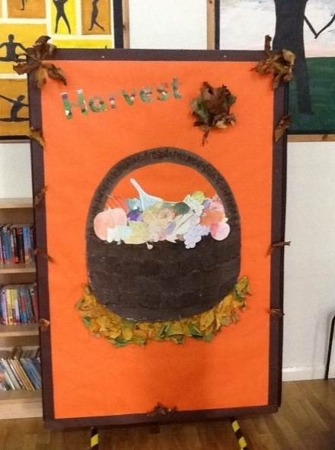


Extra-curricular clubs
At Redwood, children can attend a range of extra-curricular clubs, and these change regularly to provide as wide a range of opportunities as possible. Clubs are an excellent chance for children to learn, practise and show off their personal creativity, share their talents with others, and support each other to achieve an end goal. We have a number of sports teams and take part in sporting events such as netball tournaments, football matches, tag rugby, cross-country and Multi-Sports. We also have a singing club that takes place in school. Members of the singing club attend the Young Voices event, where they perform with a number of other schools from different parts of the country.


Educational visits
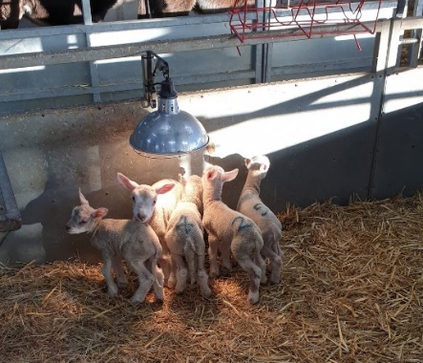
Educational visits are a fundamental and crucial part of our curriculum at Redwood. They excite, motivate and challenge the children, building on what they are learning and opening up opportunities for many new experiences and challenges. Whether it is a Reception trip to the castle, a short residential to Rand Farm for year 4 or a 4-night, year 6 residential trip to PGL, the children gain rich and memorable experiences that expand their horizons, build their self-confidence and provide them with a sense of the wider world.

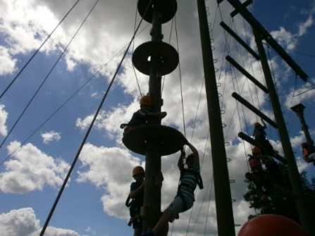

Share a story morning
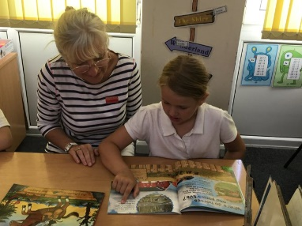
‘Share a story Morning’ allows parents and carers to come into the academy to share a story with their child or a group of children. This event takes place once a month throughout the year and aims to encourage and promote the children’s enthusiasm for reading. At Redwood, we know that reading is an integral part of the children’s development and we want to create an environment where we promote the children’s love of reading. The children really enjoy reading to an audience and having a new listener can make their reading experience more enjoyable. Within our SMSC work, we foster supporting and encouraging the social skills of the children. Share a story morning encourages the children to participate within a small group, appreciate different ideas and viewpoints when exploring a story, volunteer to read, and respect each other’s experiences and feelings.
School council
School councillors play a big role in our academy. Our School Council is comprised of children from every class across Key Stages 1 and 2, and provides an ideal opportunity for pupils to get more involved in the way the academy is run. The School Council benefits the whole academy, pupils and teachers, because it provides opportunities for pupils to communicate their feelings as well as influence decisions that are made. Councillors develop skills such as confidence, communication and negotiation. It is the responsibility of each Councillor to ensure that they express both their own views and the views of all the other pupils they represent.
Each year, the children in each class stand for election, six are shortlisted and a ballot is held, during which all children vote for their class councillors.
JRSO’s
As well as having School Council representatives, we also have JRSOs- Junior Road Safety Officers. Each year, two Year 6 pupils are chosen as our Junior Road Safety Officers, who are responsible for helping children in our academy to stay safe on and around the roads. Each year, they focus on three themes, which we look at for a half term each. At their weekly meetings, they plan assemblies to tell the other children all about the theme as well as fun competitions for the children to enter.
JHSO’s
Each year we have 2 Junior Home Safety Officers chosen from our year 6 cohort. They meet each week to work on ideas and initiatives to promote safety in the home. Themes explored and promoted throughout the academy include Bonfire Safety, Sun safety, preventing burns and scolds, fire safety and making a home fire escape plan. Our JHSO’s promote their work by planning competitions, delivering assemblies and working with groups of children.
Digital Leaders
Another role that pupils take on in our academy are the Digital Leaders (Junior Online Safety Officers). These children work with staff to promote online safety in school. Our Digital Leaders are a contact point for pupils with worries or concerns about online safety and they share their knowledge and expertise regularly with the other children through assemblies, workshops, competitions and initiatives.
Sports Crew
At Waddington Redwood Primary Academy, we also have another group of children who act as role models for the rest of our pupils. Our Sports Crew help to promote sport and being active to their fellow pupils, as well as leading fun games and activities out on the playground during lunchtimes for our EYFS and KS1 children. Our Sports Crew have a moral and social impact on the rest of our pupils, as they are inclusive in their role, developing teamwork and playing happily together. Our Sports Crew also demonstrate values such as respect, honesty and kindness in their role.
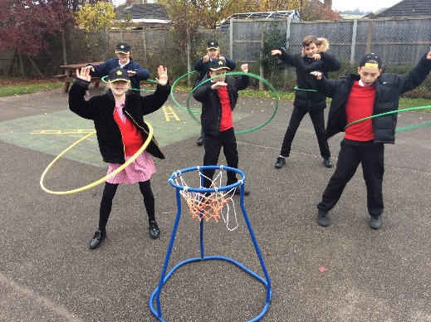

Anti-Bullying Ambassadors
During the academic year 2015-2016, Waddington Redwood took part in the Diana Award. The Diana Award is a legacy to Princess Diana’s belief that young people have the power to change the world for the better. Redwood became a part of the Diana Award is 2015 when we introduced Anti-Bullying Ambassadors in school.
At Redwood, we have six KS2 Anti-Bullying Ambassadors. These Ambassadors are responsible, along with selected adults in school, to help promote Anti-Bullying and tackle any incidences of bullying in school. Within our Anti-Bullying Ambassador team, we have two children selected to be our Anti-Bullying Ambassador Leader and a Deputy Leader.
Our Ambassadors have a range of different skills, which are essential to their job role. They are enthusiastic about their role and tackling bullying; positive role models for others to look up to; committed to their role of supporting others and they have the knowledge they need to help fellow pupils. Other traits that our Ambassadors show are good communication skills, valuing the feelings of others, recognising right and wrong, and offering their views to help others. Our Ambassadors use their social skills to appreciate the viewpoints of more than one person, helping to resolve conflict and showing respect to others. The Ambassadors also accept, respect and celebrate diversity in their role by supporting all pupils across the academy.
As part of their job role, our Anti-Bullying Ambassadors have a meeting every Friday lunchtime where any issues are discussed and planned support is put in place. The Ambassadors have implemented ‘Bully’ and ‘Sorry’ Boxes (where any issues or worries are posted or where any sorry notes can be put) and have had and continue to have a huge input in running our yearly events such as Anti-Bullying Week, Kindness Day, British Values Day and Children’s Mental Health Week.

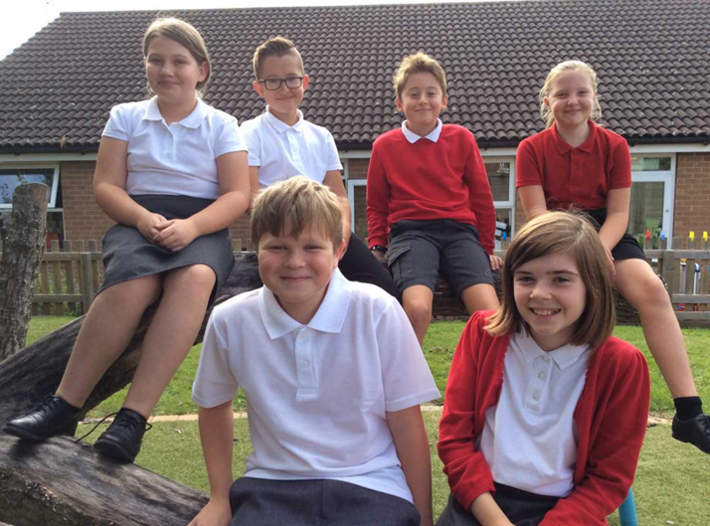

Pastoral support
At Redwood, we have a super team of staff who offer many different forms of support for our pupils and families. One form of support we offer is pastoral care. Pastoral care is provided at Redwood when concerns are raised by parents, staff or children themselves. Many children need pastoral support at some time in their primary school lives and we pride ourselves on offering effective support where needed.
Our Lead Behaviour and Pupil Support Officer provides support in the form of weekly ‘check-ins’ with identified children, being present at meetings between staff and parents or staff and children. Support is given according to need, and may involve specific programmes, raising awareness or providing strategies or advice.
We recognise the challenges faced by families in the Forces, and ensure that support is in place to aid transition to our school. We also may offer support while attending our school and transition to another school, should this be applicable. A weekly social circle enables children of Forces families to meet, share experiences and discus any concerns they have.
Increased support is put into place at times when parents are deployed, including liaison with parents and carers. The forces group takes place one lunchtime each week, where children who have family members in the forces can create cards, themed presents, welcome home banners or just have a chat about any worries or feelings they may have concerning their absent family members. Many of our forces children use this session and find it to be very useful to helping them cope with their family circumstances.
All of the children in our academy have access to an open chat room held on Thursday lunchtimes. This enables our pupils to share anything from any worries and concerns to exciting activities or experiences in their life.
Redwood recognises the important role our Young Carers have and we support them by regularly meeting. During these meetings, we engage with them whilst doing craft work giving them the opportunity to discuss anything that is concerning or worrying them. We ensure they are listened to and support them in every way possible.
Mental Health Day
This year Waddington Redwood Primary Academy took part in World Mental Health Day. We took part in this campaign by wearing yellow to support Young Minds. We wore yellow to show our support for young people, making them aware that they are not alone with their mental health. Whether it was a scarf, top, socks or a creation of their own, we dug out our most yellow clothes and wore them with pride! We enjoyed our fun filled day, supporting this great cause.
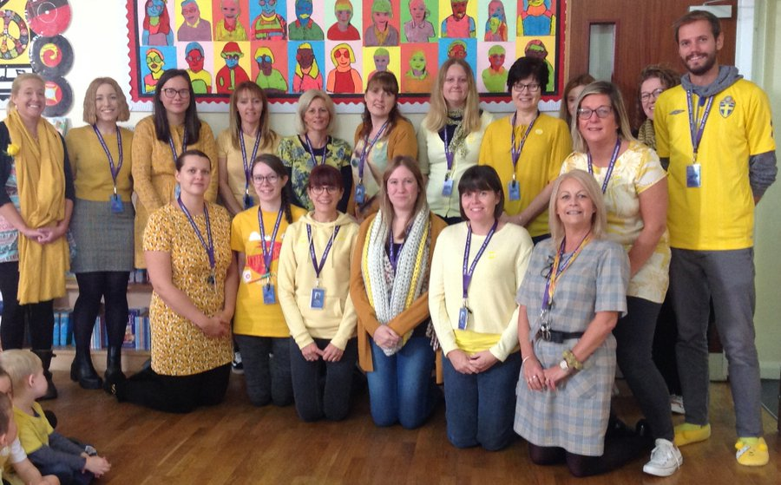

Aspire Week
Every four years, at Waddington Redwood Primary Academy, we hold a week where we celebrate the gifts and talents of our pupils, staff and our local community. Our latest celebration focused on exploring jobs and careers that we might aspire to do. We therefore called our celebration- Aspire Week.

Over the duration of Aspire Week, our pupils experienced what different jobs entail. During the week, we had many different professionals come into the academy and share their role with us. To list a few we had: sports coaches from Synergy; different professions from the RAF; florists; martial art teachers; firefighters and even the police enjoyed a visit to our pupils. Some children even managed to go outside of the academy and visit Pizza Express to explore the job role of a chef!

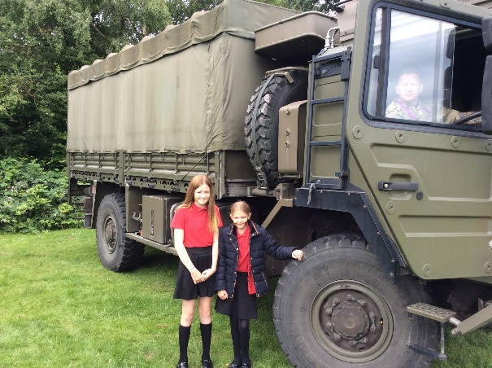
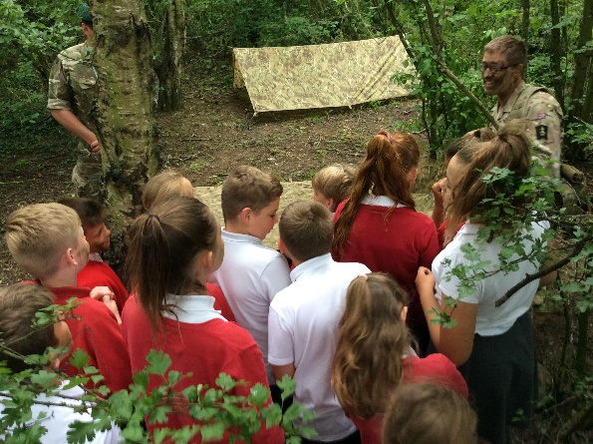

Visitors in school
At Waddington Redwood Primary Academy, we encourage and provide opportunities to have visitors into our academy to develop the children’s learning and give them rich learning opportunities.
Tractors in School Scheme
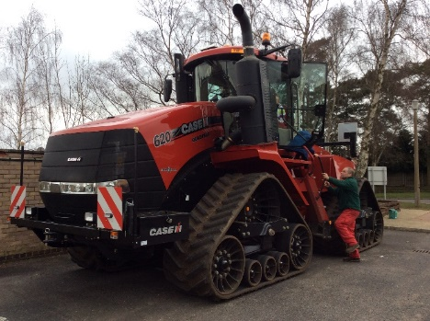

The pupils and staff at Waddington Redwood Primary Academy were fortunate to receive a visit from local farmer Andrew Ward as part of an initiative to encourage more awareness of farming in the local community. The ‘Tractors into School’ scheme links farmers with local schools and on Tuesday 3rd March we welcomed Andrew into our academy. He brought two of his working tractors along with a variety of seeds and produce to show pupils where the ingredients for some common foods such as cereal, bread and biscuits come from. Throughout the day, pupils and staff were given an expert talk in crops and food production and the modern technology incorporated into tractors today. We even had the opportunity to sit on the tractor! To promote this initiative and raise the profile of farming, we opened our doors to several film and radio crews from local news crews Lincs FM and ITV Calendar. The whole day was well received and very informative. There are now plans for pupils and staff to visit Andrew at his farm to see how the tractors and other machinery are put to use in the fields.

Ancient Greek Experience
As part of our curriculum, we regularly have visitors into our academy who carry out workshops with the children based on their learning. This year we had a visit from Gareth Pickard, a STEM ambassador from the RAF Coningsby. He came in to work alongside the Year 5 and 6 children to support their learning about the Ancient Egyptians using VR kits. The children were able to virtually explore artefacts and pyramids extending their learning beyond the classroom.
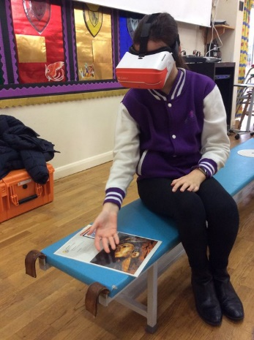

Armistice Day
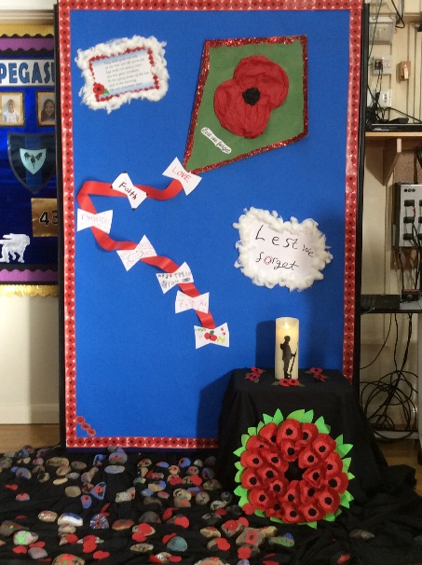
This year we had visitors from the British Legion for our Armistice Day assembly. Our Year 6 and Forces children led a Remembrance Day assembly for the rest of the academy. The children read poems and led a two-minute silence. The children laid down poppies and decorated stones to remember those who fought and lost their lives. It was a beautiful service.


